New energy: smart cities test new urban technologies
Cities represent three quarters of energy consumption and 80% of CO2 emissions worldwide, and with urbanisation expected to continue, a growing number of ‘Lighthouse’ cities across Europe have taken up the challenge of testing new ‘smart’ energy-saving solutions in large-scale test-beds.

This year’s European Energy Sustainable Week, will bring together and feature nine smart city ‘Lighthouse’ projects in a special policy session entitled “smarter is cleaner”.

Representatives from these smart city projects will present new energy products, discuss environmental policies and share a catalogue of learning on how to grow a new market of smarter, more sustainable energy solutions and create a new generation of jobs.

GrowSmarter is one of the nine Smart city projects.

“This is what GrowSmarter is all about: creating jobs and reducing greenhouse gas emissions.” says Gustaf Landahl, coordinator of the Lighthouse project, GrowSmarter “5 out of 20 business partners have been able to sell their solutions to other cities by using our demonstration sites in the Lighthouse Cities: Stockholm, Cologne and Barcelona.”

“GrowSmarter shows that cities and industry can help Europe Grow Smarter. We are only halfway through the project but next year demonstrations of the solutions will be really up and running and I look forward to continuing to help expand the market for all 20 involved business partners, and reaching the Paris Climate targets.”

Smart city projects are part of a growing trend, redefining our urban environment and how we manage our use of resources. Working hand-in-hand with industrial partners, 27 lighthouse cities and 30 follower cities are paving the way for a new energy ecosystem collectively create low-carbon and resource-efficient economy.

“Smart city projects such as GrowSmarter offer a real opportunity to see how ‘smart’ solutions work in practice. It also helps to test new business models and products to support cities in the transition to more resource-efficient environments” says Peter Andersson from Veolia Nordics.

“Participating in events such as European Sustainable Energy Week, is a great opportunity to meet cities face-to face and show them the innovative products we have developed and the potential they can create.”

All nine smart city projects on show at the European Sustainable Energy Week are funded through the European Union’s Horizon 2020 research and innovation funding programme.

More information can be found at: www.smartcities-infosystem.eu

Word count: 379

Contact:
Helen Franzen, Coordinator
(Communications lead for GrowSmarter)
ICLEI – Local Governments for Sustainability,
helen.franzen@iclei.org

NOTES TO EDITOR:
List of project involved: RemoUrban, Triangulum, GrowSmarter, Replicate, SmarterTogether, SharingCities, SmartEnCity, RUGGEDISED, mySMARTlife. These can be found on the website:

More information about the Horizon2020 funding programme can be found here: https://ec.europa.eu/programmes/horizon2020/en/what-horizon-2020

A manifesto formally recognising cooperation between the Lighthouse City projects was signed in Nottingham (United Kingdom) on 29 March 2017: http://www.smartcities-infosystem.eu/newsroom/news/lighthouse-projects-join-forces-replicate-smart-city-solutions

Many of the projects have City Interest Groups where towns and cities from outside the projects are invited to follow the projects and participate in the capacity activities on offer.

About GrowSmarter
GrowSmarter (www.grow-smarter.eu) brings together cities and industry to integrate, demonstrate and stimulate the uptake of ‘12 smart city solutions’ in energy, infrastructure and transport, to provide other European cities with insights and create a ready market to support the transition to a smart, sustainable Europe.

GrowSmarter project partners
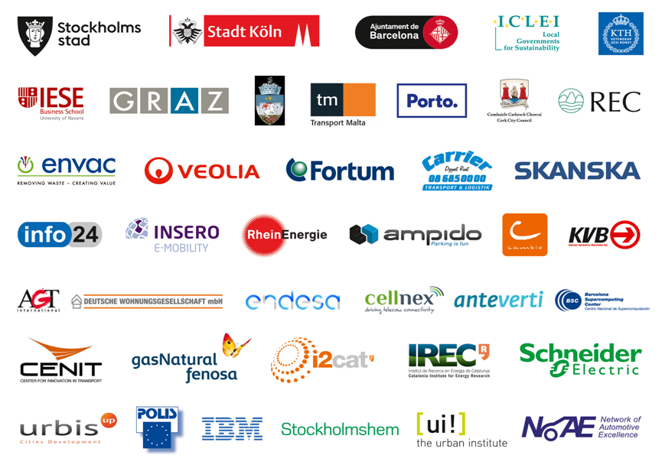

About Horizon 2020
‘Horizon 2020 is the biggest EU Research and Innovation programme ever with nearly €80 billion of funding available over 7 years (2014 to 2020) – in addition to the private investment that this money will attract. It promises more breakthroughs, discoveries and world-firsts by taking great ideas from the lab to the market.’ For reference and more information visit: http://ec.europa.eu/programmes/horizon2020/en/what-horizon-2020

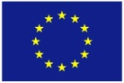
The sole responsibility for the content of this document lies with the author and in no way reflects the views of the European Union.

This project has received funding from the European Union's Horizon 2020 research and innovation programme under grant agreement no 646456.

